August Travel Note from Ramelle & Michael

Dear Friends and Fellow Travelers,

Summer is in full swing here in the Berkshires of Massachusetts. We are checking our calendars daily to keep up with the summer performance schedules here: dance, music, theatre and art are all in abundance. Life is a bustle in the village this summer.

With only a few short weeks left, we are looking ahead to two Ecuador tours in 2015. Can you join us?

January 20 - 31, 2015
Cuenca, Quito & the restored 1602 Hacienda Cusin
A gentle tour with spectacular views of the national parks, the markets and museums: 11 nights - $2400 per person double occupancy.

We start this adventure in Guayaquil, Ecuador at sea level. After a tour of the city, we begin the climb through the different ecosystems, gradually increasing altitude as we move inland through ever changing terrain. We see the farmland of southern Ecuador, the valleys and ridge views of the Pacific ocean, up through the plateaus to the spectacular city of Cuenca, a world Heritage Site and beautiful colonial city. This area is becoming a popular destination for American retirees. Here the temperature and climate are considered perfect all year round.
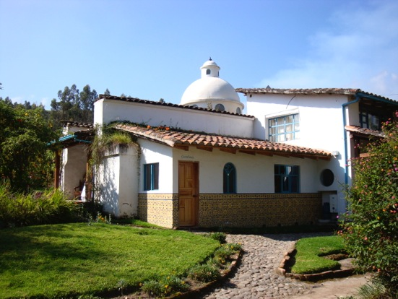
We’ll visit the Caja National Park, one of many in this small country. We explore small villages with abundant crafts and different markets in abundance. We visit the hat making collectives and admire colonial churches that are masterpieces of the early era post-conquest. See www.newviewtours.com/gallery
After three days in Cuenca, it is a short flight to Quito, the country’s capital at 9,200 feet. We visit galleries, colonial churches, the pre-Columbian museum, the City Museum, and we will enjoy the finest restaurants, many located in restored classic haciendas.
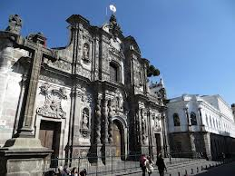
(La Compania – photo by Ramelle)

We will transfer by van across the equator. We stop here - in the middle of the world, "El Mitad del Mundo” where the earliest civilizations understood the alignment of the sun and the moon to the earth in perfect balance with the seasons.
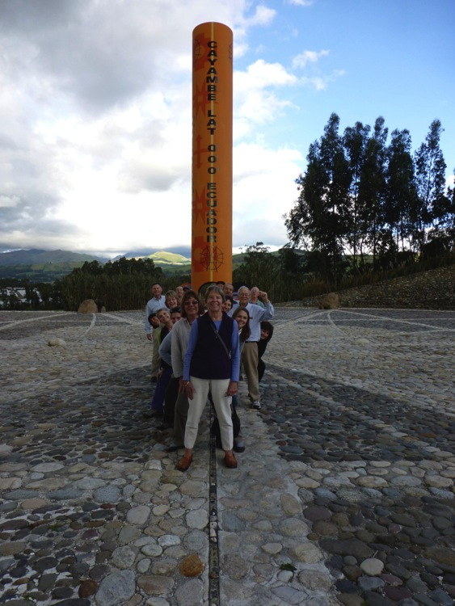
(On the equatorial line – Berkshire Group 2012)
It is only a few kilometers to the high sierras where we stay at the renowned 1602 Hacienda Cusin - a restored by owner and our host, Nik Millhouse. Originally a farm, it is now a 30 acre compound, mostly gardens, always improving, always setting a new standard for comfort and convenience and special service.
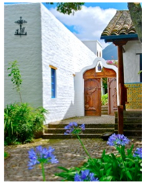
March 9 - 19, 2015

Gardens and Trails:
Refresh and Revisit the High Sierra of Ecuador; tour the Cloud Forest of Intag; practice yoga daily and enjoy a quality group experience. This tour visits four different ecosystems in the small country.
10 days $2200

We enjoy the country hospitality of Las Palmeras Inn www.laspalmerasinn.com near the markets of Otavalo, the variety of plant and wild life at El Refugio in the Intag Cloud Forest.
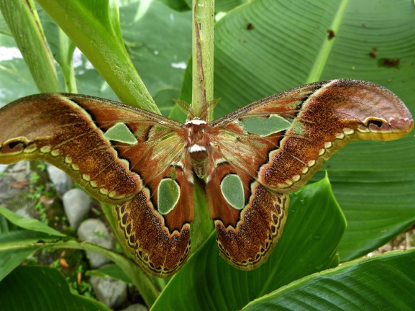
(Moth – photo by Peter Joost)

We explore the exceptional hand carved colonial churches in Quito, and weave our way down the Valley of the Volcanoes to the beautiful Tombopaxi Inn at the base of Cotapaxi volcano. 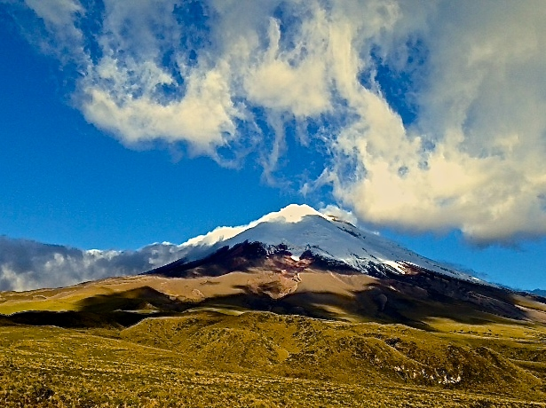
(Cotopaxi- photo by Nik Millhouse)
Then we end with a string of days and abundant activities at Hacienda Cusin. Hike, horseback ride, read, relax, restore, reflect, return with us!

About Our Tours:

Our small group tours have brought together interesting friends and acquaintances from all across the country. Our focus is to design the details based on the activity level of the participants. We adjust the activity level of each tour to you: the travelers. New View Tours travelers prefer days full of activity, nights in front of warm fires with friends and plenty of options for individual choice along the way.

We look forward to hearing from you soon!

Happy Trails!

Ramelle and Michael

ramelle@newviewtours.com - Tel 336 416 2390
mp@newviewtours.com - Tel 413 717 5459
www.newviewtours.com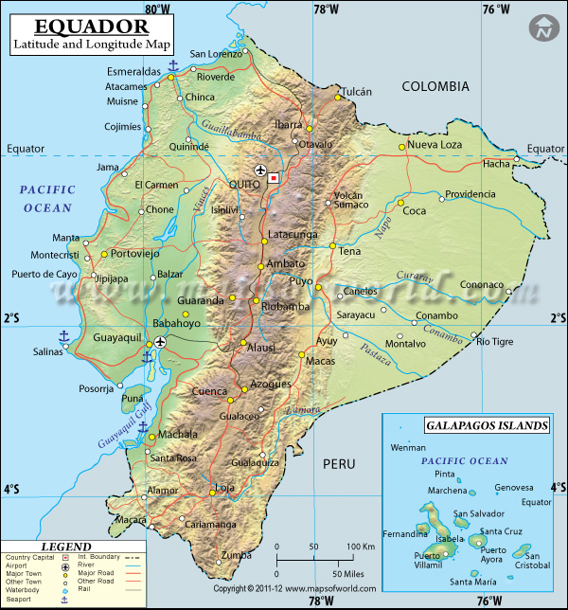
(Map of Ecuador –courtesy of Google maps!)

